CSA1519- CLOUD COMPUTING FOR BIG DATA ANALYTICS
LAB EXPERIMENTS

NAME : P SUDHARSHAN REDDY REG.NO: 192372204
EXPNO 15: CREATE A SNAPSHOT OF A VM AND TEST IT BY LOADING THE
PREVIOUS VERSION/CLONED VM

AIM: To create a snapshot of a vm and test it by loading the previous version/cloned vm
PROCEDURE:
STEP 1: GOTO VMWARE WORKSTATION.
STEP 2: CREATE FILES ON DESKTOP.
STEP 3: CLICK ON VM AND SELECTS SNAPSHOT-> TAKE SNAPSHOT.
STEP 4: SNAPSHOT IS BEING DONE

IMPLEMENTATION:

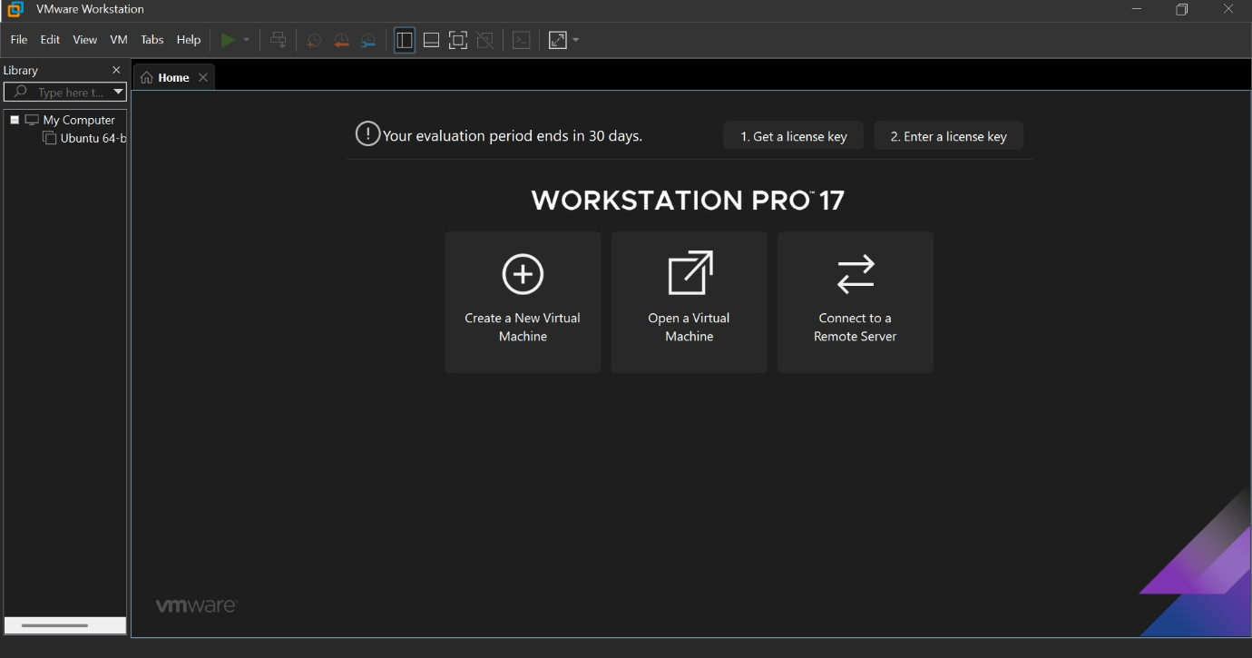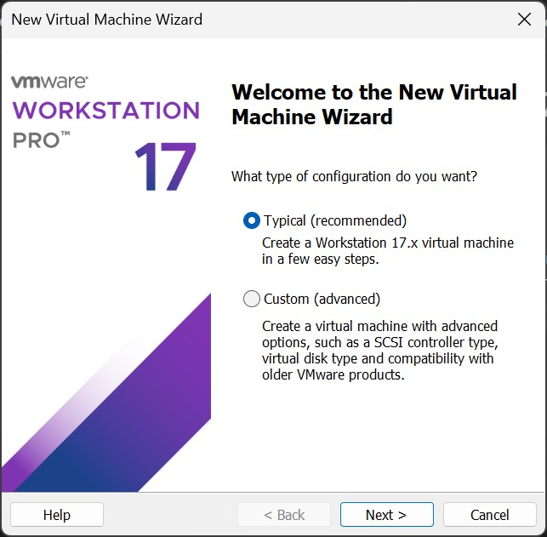

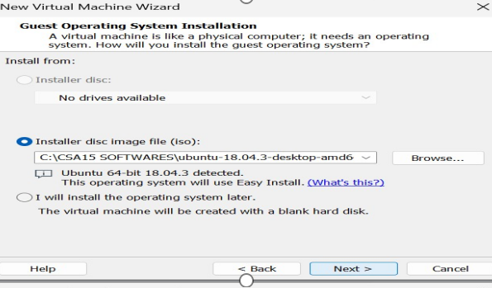

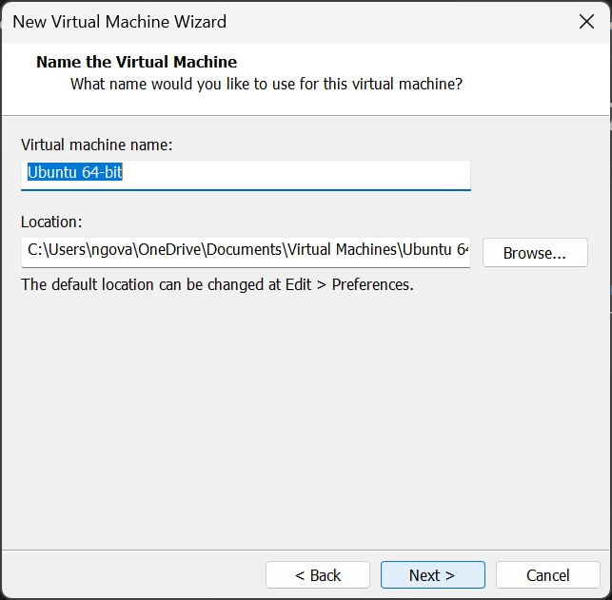

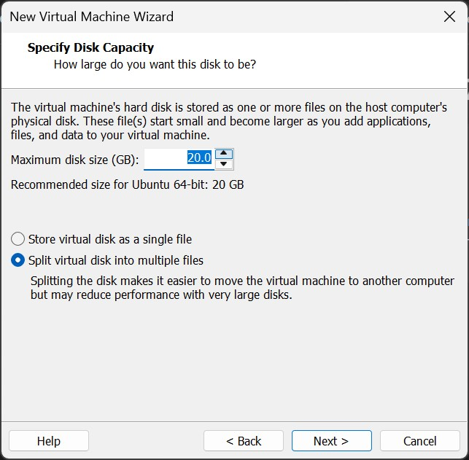

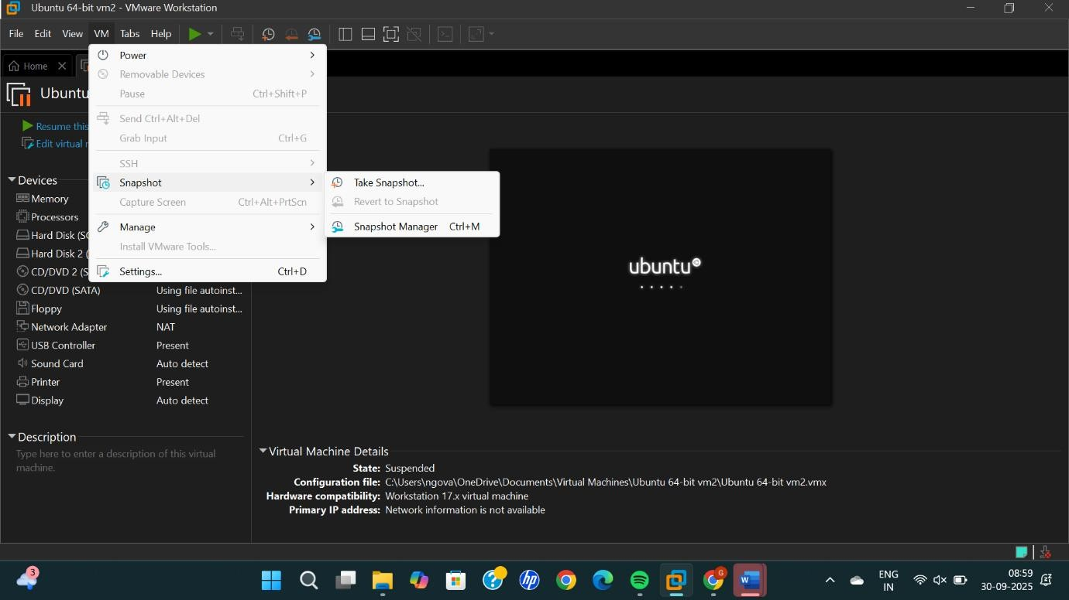
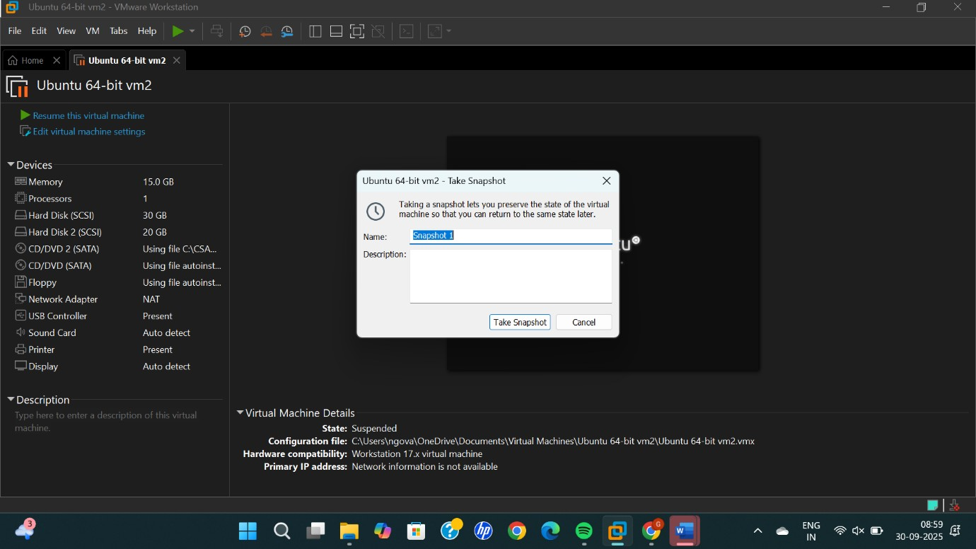

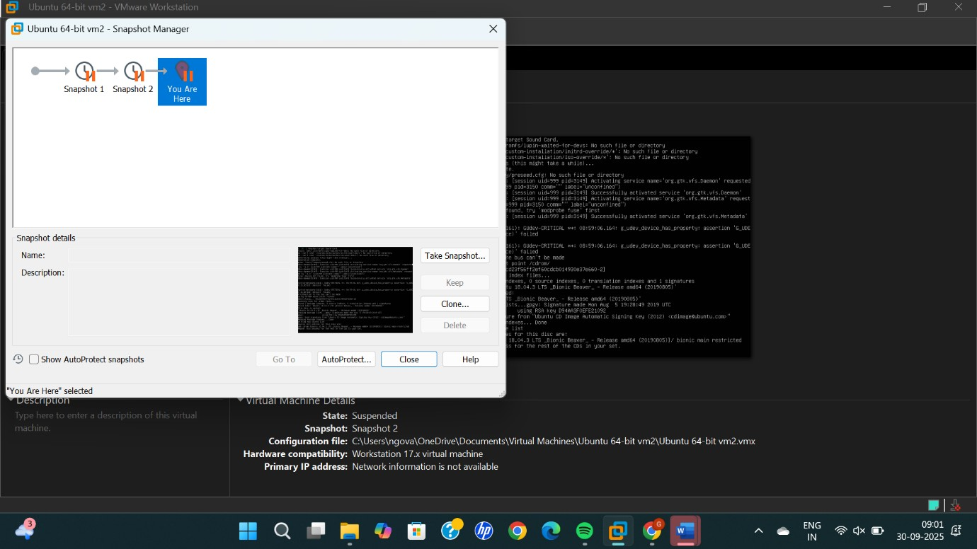

RESULTS
SUCCESSFULLY A SNAPSHOT OF A VM AND TEST IT BY LOADING THE
PREVIOUS VERSION/CLONED VM

